Print Out Source Code Program

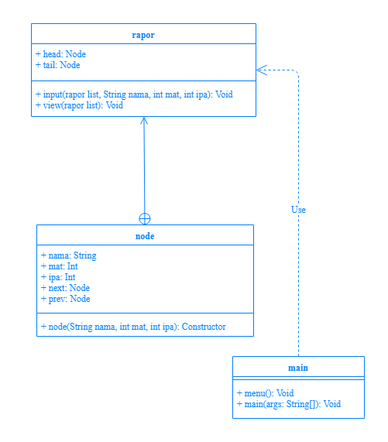

Print Out Source Code Program

class rapor {

private static class node{

String nama;

int mat,ipa;

node next,prev;

node(String nama, int mat, int ipa){

this.nama = nama;

this.mat = mat;

this.ipa = ipa;

this.next = null;

this.prev = null; }}

node head,tail;

Keterangan Source Code :

------------------------------------------------------------------------------------------------------------------------------------------------------------------------------------------------------------------------------------------------------------------------------------------------------------------------------------------------------------------------------------------------------------------------------------------------------------------------------------------------------------------------------------------------------------------------------------------------------------------------------------------------------------------------------------------------------------------------------------------------------------------------------------------------------------------------------------------------------------------------------------------------------------------------------------------------------------------------------------------------------------------------------------------------------------------------------------------------------------------------------------------------------------------------------------------------------------------------------------------------------------------------------------------------------------------------------------------------------------------------------------------------------------------------------------------------------------------------------------------------------------------------------------------------------------------------------------------------------------------------------------------------

Print Out Source Code Program

void input(rapor list, String nama, int mat, int ipa){

node data_siswa = new node(nama, mat, ipa);

if(list.head == null){

list.head = data_siswa;

list.tail = data_siswa;

}else{

data_siswa.next = list.tail;

data_siswa.prev = null;

list.tail.prev = data_siswa;

list.tail = data_siswa; }}

void view(rapor list){

node view = list.tail;

System.out.println("Nilai Siswa\n");

while(view != null){

System.out.println(view.nama+"\nNilai Matematika= "+view.mat+"\nNilai IPA= "+view.ipa+"\n");

view = view.next; }}}

Keterangan Source Code :

------------------------------------------------------------------------------------------------------------------------------------------------------------------------------------------------------------------------------------------------------------------------------------------------------------------------------------------------------------------------------------------------------------------------------------------------------------------------------------------------------------------------------------------------------------------------------------------------------------------------------------------------------------------------------------------------------------------------------------------------------------------------------------------------------------------------------------------------------------------------------------------------------------------------------------------------------------------------------------------------------------------------------------------------------------------------------------------------------------------------------------------------------------------------------------------------------------------------------------------------------------------------------------------------------------------------------------------------------------------------------------------------------------------------------------------------------------------------------------------------------------------------------------------------------------------------------------------------------------------------------------------------

Print Out Source Code Program

import java.util.Scanner;

public class main {

static void menu(){

System.out.println("Rapor Elektrik");

System.out.println("1.Input Data");

System.out.println("2.Tampil Data");}

public static void main(String[] args) {

Scanner input = new Scanner(System.in);

rapor nilai = new rapor();

String nama;

int mat, ipa, pilih;

do{

menu();

System.out.print("Pilih: ");pilih = input.nextInt();

System.out.println();

Keterangan Source Code :

------------------------------------------------------------------------------------------------------------------------------------------------------------------------------------------------------------------------------------------------------------------------------------------------------------------------------------------------------------------------------------------------------------------------------------------------------------------------------------------------------------------------------------------------------------------------------------------------------------------------------------------------------------------------------------------------------------------------------------------------------------------------------------------------------------------------------------------------------------------------------------------------------------------------------------------------------------------------------------------------------------------------------------------------------------------------------------------------------------------------------------------------------------------------------------------------------------------------------------------------------------------------------------------------------------------------------------------------------------------------------------------------------------------------------------------------------------------------------------------------------------------------------------------------------------------------------------------------------------------------------------------------

Print Out Source Code Program

switch(pilih){

case 1:

input.nextLine();

System.out.print("Masukkan Nama: ");nama = input.nextLine();

System.out.print("Masukkan Nilai Matematika: ");mat = input.nextInt();

System.out.print("Masukkan Nilai IPA: ");ipa = input.nextInt();

System.out.println();

nilai.input(nilai, nama, mat, ipa);

break;

Keterangan Source Code :

------------------------------------------------------------------------------------------------------------------------------------------------------------------------------------------------------------------------------------------------------------------------------------------------------------------------------------------------------------------------------------------------------------------------------------------------------------------------------------------------------------------------------------------------------------------------------------------------------------------------------------------------------------------------------------------------------------------------------------------------------------------------------------------------------------------------------------------------------------------------------------------------------------------------------------------------------------------------------------------------------------------------------------------------------------------------------------------------------------------------------------------------------------------------------------------------------------------------------------------------------------------------------------------------------------------------------------------------------------------------------------------------------------------------------------------------------------------------------------------------------------------------------------------------------------------------------------------------------------------------------------------------

Print Out Source Code Program

case 2:

nilai.view(nilai);

break;

}

}while (pilih!=3);

}}

Keterangan Source Code :

------------------------------------------------------------------------------------------------------------------------------------------------------------------------------------------------------------------------------------------------------------------------------------------------------------------------------------------------------------------------------------------------------------------------------------------------------------------------------------------------------------------------------------------------------------------------------------------------------------------------------------------------------------------------------------------------------------------------------------------------------------------------------------------------------------------------------------------------------------------------------------------------------------------------------------------------------------------------------------------------------------------------------------------------------------------------------------------------------------------------------------------------------------------------------------------------------------------------------------------------------------------------------------------------------------------------------------------------------------------------------------------------------------------------------------------------------------------------------------------------------------------------------------------------------------------------------------------------------------------------------------------------

Print Out Source Code Program

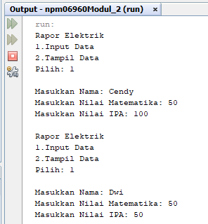

Keterangan Source Code :

------------------------------------------------------------------------------------------------------------------------------------------------------------------------------------------------------------------------------------------------------------------------------------------------------------------------------------------------------------------------------------------------------------------------------------------------------------------------------------------------------------------------------------------------------------------------------------------------------------------------------------------------------------------------------------------------------------------------------------------------------------------------------------------------------------------------------------------------------------------------------------------------------------------------------------------------------------------------------------------------------------------------------------------------------------------------------------------------------------------------------------------------------------------------------------------------------------------------------------------------------------------------------------------------------------------------------------------------------------------------------------------------------------------------------------------------------------------------------------------------------------------------------------------------------------------------------------------------------------------------------------------------

Print Out Source Code Program

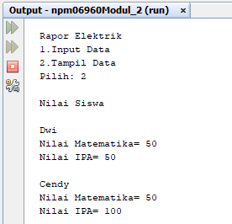

Keterangan Source Code :

------------------------------------------------------------------------------------------------------------------------------------------------------------------------------------------------------------------------------------------------------------------------------------------------------------------------------------------------------------------------------------------------------------------------------------------------------------------------------------------------------------------------------------------------------------------------------------------------------------------------------------------------------------------------------------------------------------------------------------------------------------------------------------------------------------------------------------------------------------------------------------------------------------------------------------------------------------------------------------------------------------------------------------------------------------------------------------------------------------------------------------------------------------------------------------------------------------------------------------------------------------------------------------------------------------------------------------------------------------------------------------------------------------------------------------------------------------------------------------------------------------------------------------------------------------------------------------------------------------------------------------------------